Kavya Gundala

05-01-2024

**Data Lakehouse:**

* **Data Lakehouse** is a container for all data, analytics and AI needs. It leverages the scalability and flexibility of **data lakes** and the reliability and performance of **data warehouses**, allowing organizations to store and process structured and unstructured data in a single system.

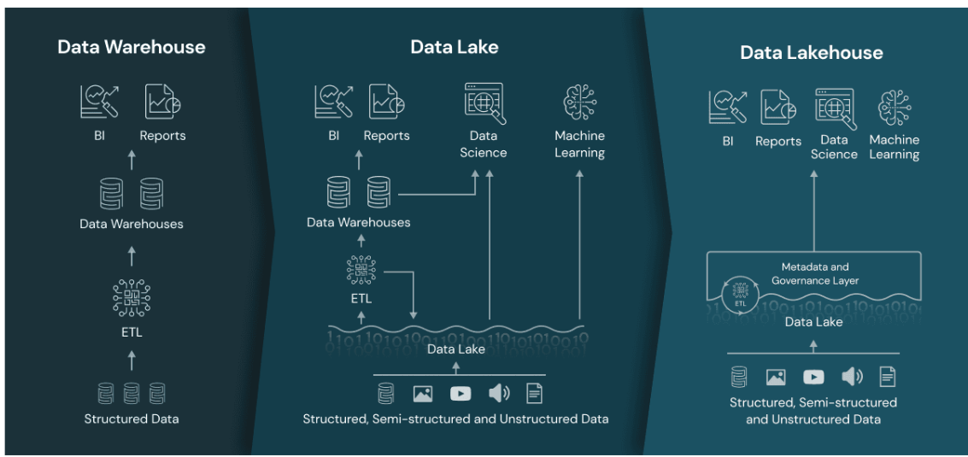

* The Lakehouse platform is built on top of Delta Lake, which is an open-source storage layer that adds reliability, scalability, and performance to data lakes.

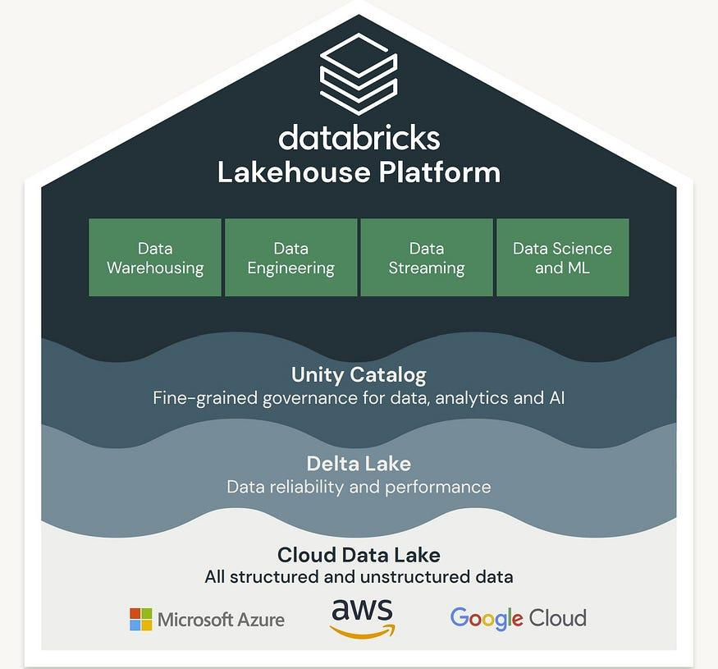

* Data Lake provides a powerful set of features for managing data in a lakehouse architecture. It is a optimized layer that allows to store and manage various file formats, Parquet, Delta Lake, and ORC.
* Databricks Delta Live Tables provide one of the key solution to build and manage, reliable and robust data engineering pipelines that can load the Streaming and batch data and deliver high-quality data on the Lakehouse Platform.

**Features of Lakehouse:**

* ACID transactions: Lakehouse provide transactional guarantees on data updates and deletions, ensuring data consistency and reliability.
* Schema enforcement: Lakehouse platforms enforce schemas on data, which provides robust governance and auditing mechanisms along with ensuring data quality and consistency.
* Scalability & Performance: Lakehouse is designed to scale horizontally, allowing organizations to process and analyze large amounts of data efficiently. It uses distributed computing techniques to process data quickly which improves query performance.
* Flexibility: Lakehouse platforms are designed to work with a wide range of data sources and file formats, irrespective of their structured forms. Making it easy to integrate with existing data pipelines and workflows.
* Unified metadata management: Lakehouse platforms provide a unified way to manage metadata across multiple data sources, making it easier to discover, access, and query data.

**Delta Live Tables:**

* Delta Live Tables or DLT is one of the best way to do ETL process in Lakehouse. It’s responsible for creating, maintaining and testing the data flow pipelines using a declarative approach, which helps data engineer to focus more on the getting the value out of data rather than focusing on tools.
* Delta live tables is solely responsible for performing data transformation and managing the task orchestration, cluster management, monitoring, data quality, and error handling.

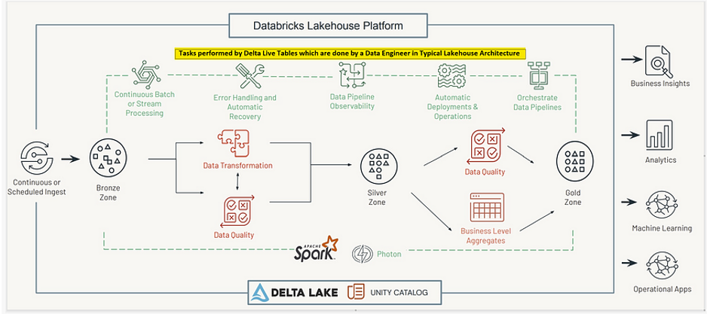

Advantages of Delta Live Tables:

* Accelerates the ETL Process: Declare SQL or Python and DLT automatically orchestrates the DAG, handles retries, changing data
* Automatically manage your infrastructure: Automatically manages complex tedious activities like recovery, auto-scaling, and performance optimization against the workflow.
* Ensure high data quality: Deliver reliable data with built-in quality controls, testing, monitoring, and enforcement.
* Unify batch and streaming: Get the simplicity of SQL with freshness of streaming with one unified API.

**Azure Data Factory:**

* Azure Data Factory is a cloud-based data integration service that allows you to create data-driven workflows in the cloud for orchestrating and automating data movement and data transformation.
* ADF does not store any data itself. It allows you to create data-driven workflows to orchestrate the movement of data between supported data stores and then process the data using compute services in other regions or in an on-premise environment. It also allows you to monitor and manage workflows using both programmatic and UI mechanisms.
* The Data Factory service allows you to create data pipelines that move and transform data and then run the pipelines on a specified schedule (hourly, daily, weekly, etc.). This means the data that is consumed and produced by workflows is time-sliced data, and we can specify the pipeline mode as scheduled (once a day) or one time.

**Creating Azure Data Factory Pipeline:**

* Here, In ADF Pipeline we create a source and destination storage accounts for data storage.
* So let’s create a source storage account “kavyastorage” and go to containers tab and create a folder ”kavyacontainer1” to upload data files into it.

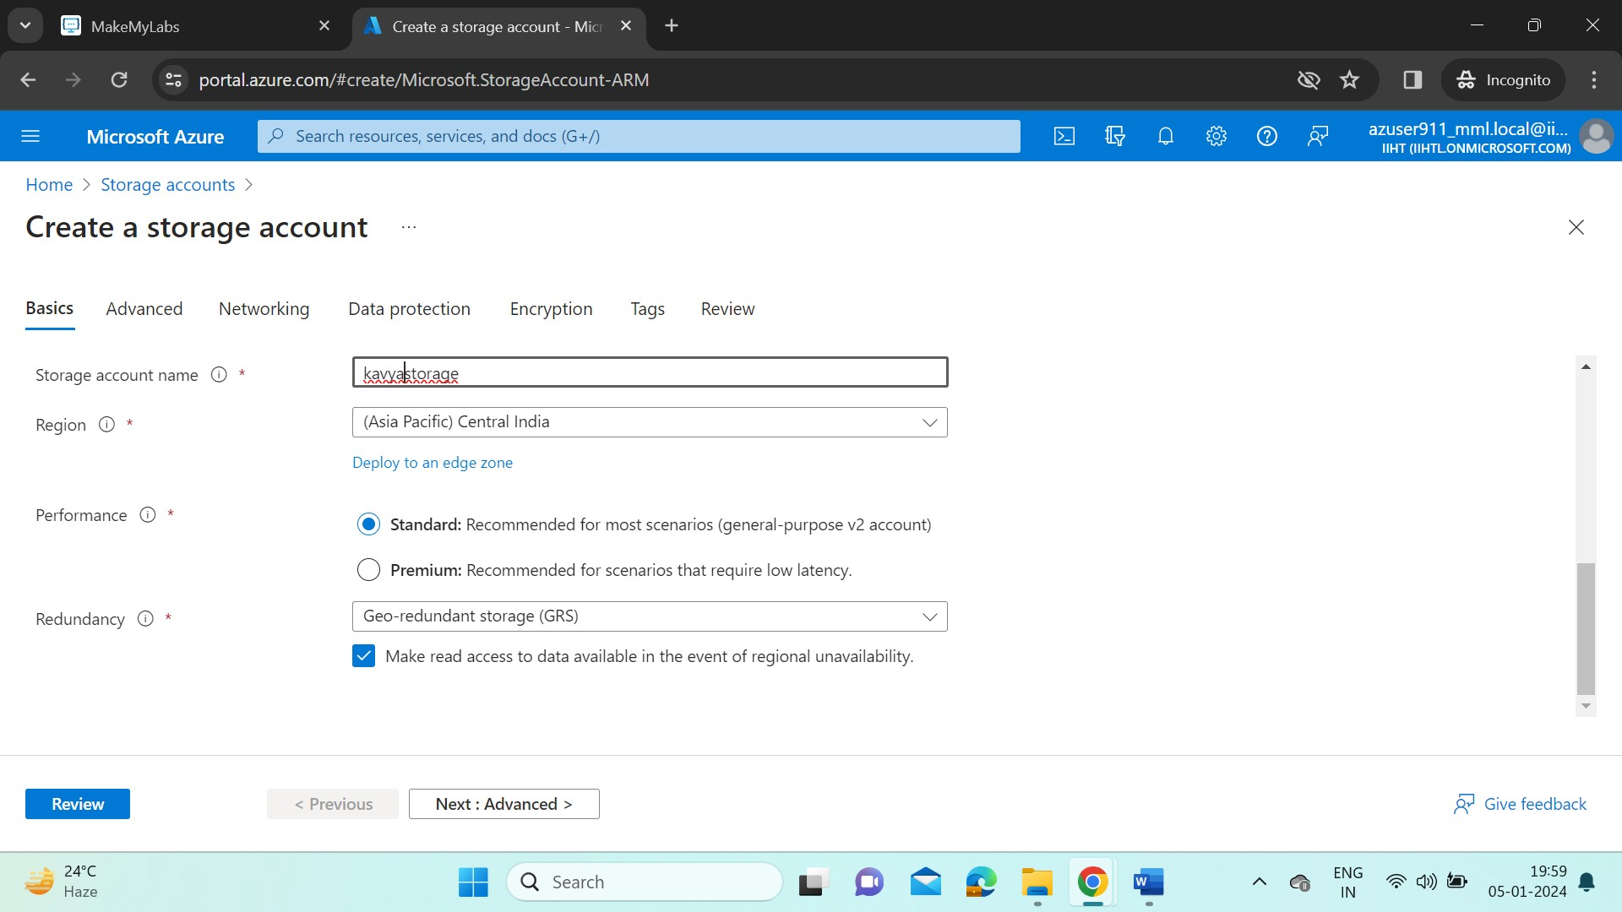

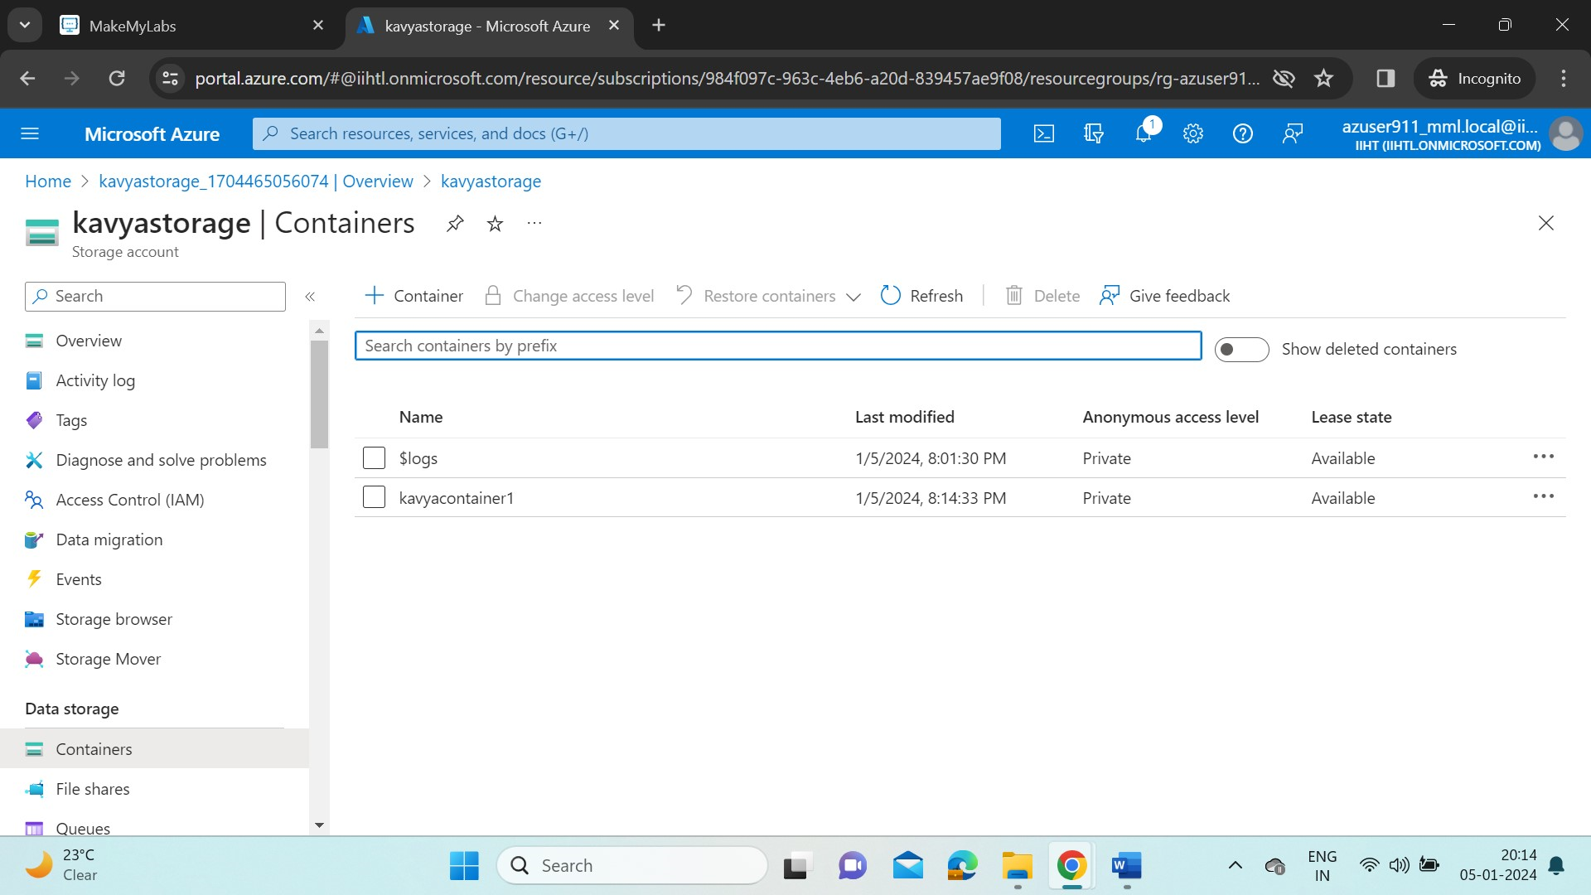

* Here, in this container we upload data files as a blob storage. So a blob storage can handle unstructured data such as .csv, .jpg, .png, .mkv, .gif etc..
* Now in this container I’ve uploaded a Product_details.csv file.

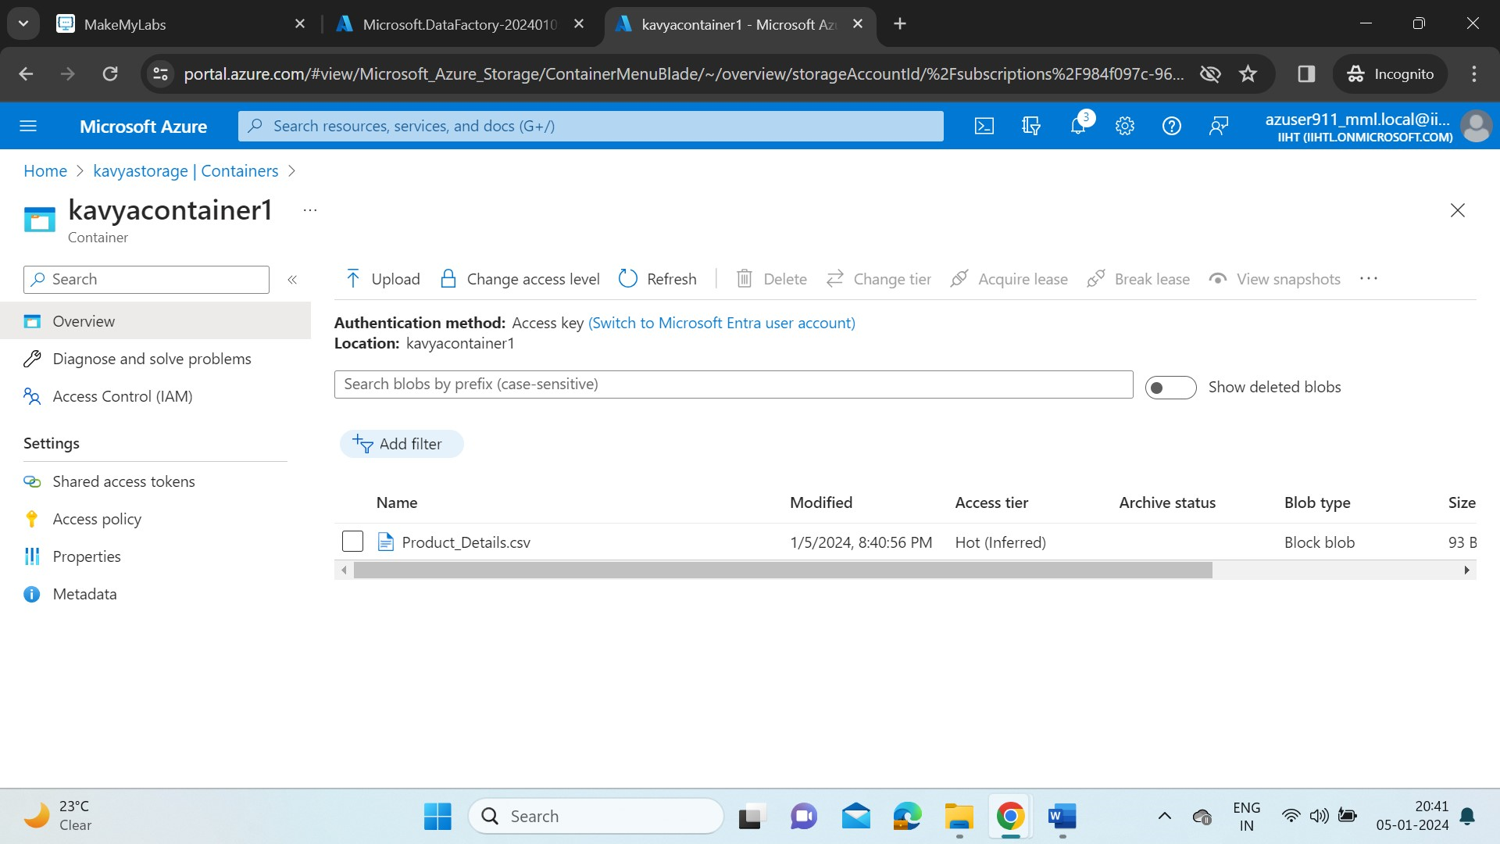

* Now let’s create a data lake storage gen2 storage (built on blob storage with extra features such as low-cost, high-availability, better fault recovery management).
* So create a gen2 storage account “kavyastoragegen2”. ADLS Gen2 will be enabled when in advanced tab “Enable hierarchical namespace” is checked.

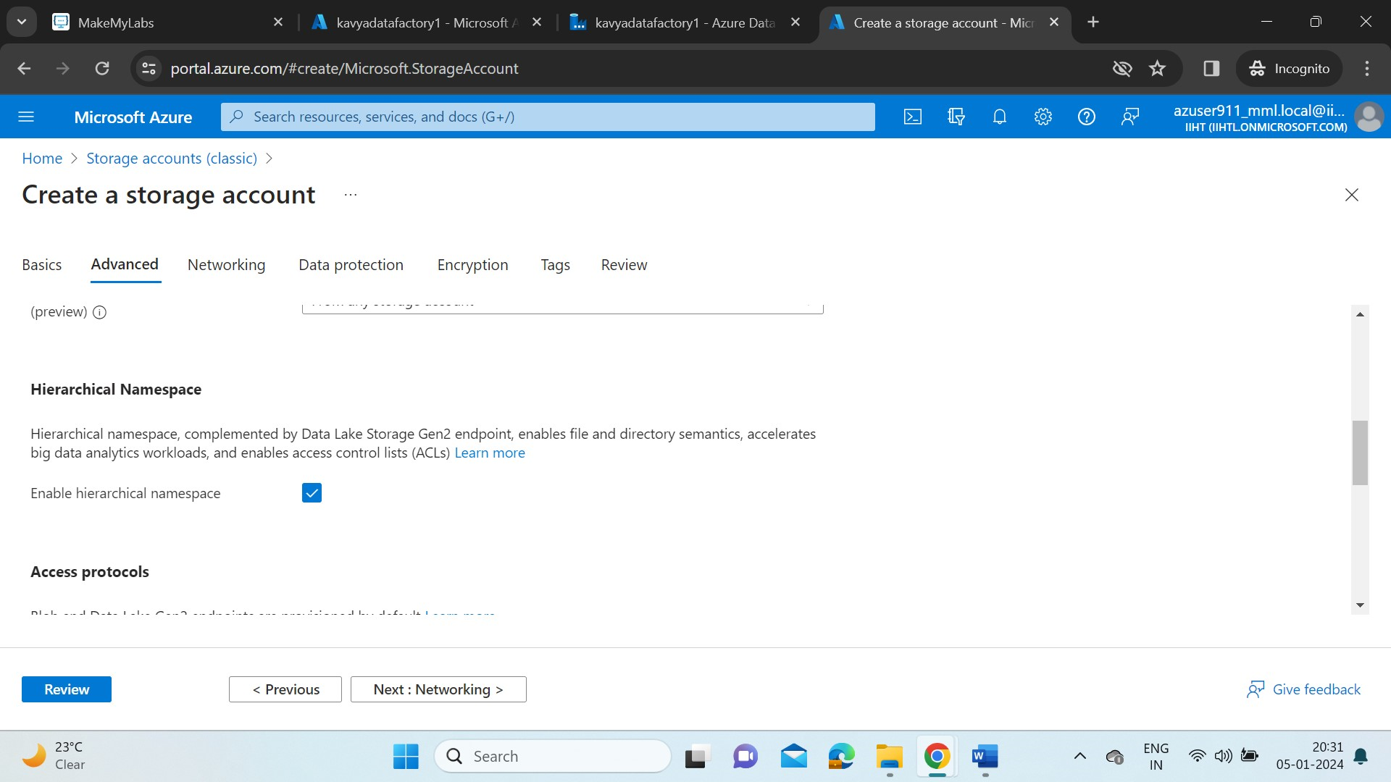

* This is the destination storage account in our pipeline. So to store data in this account, click on containers tab and then create a container “output” with no data.

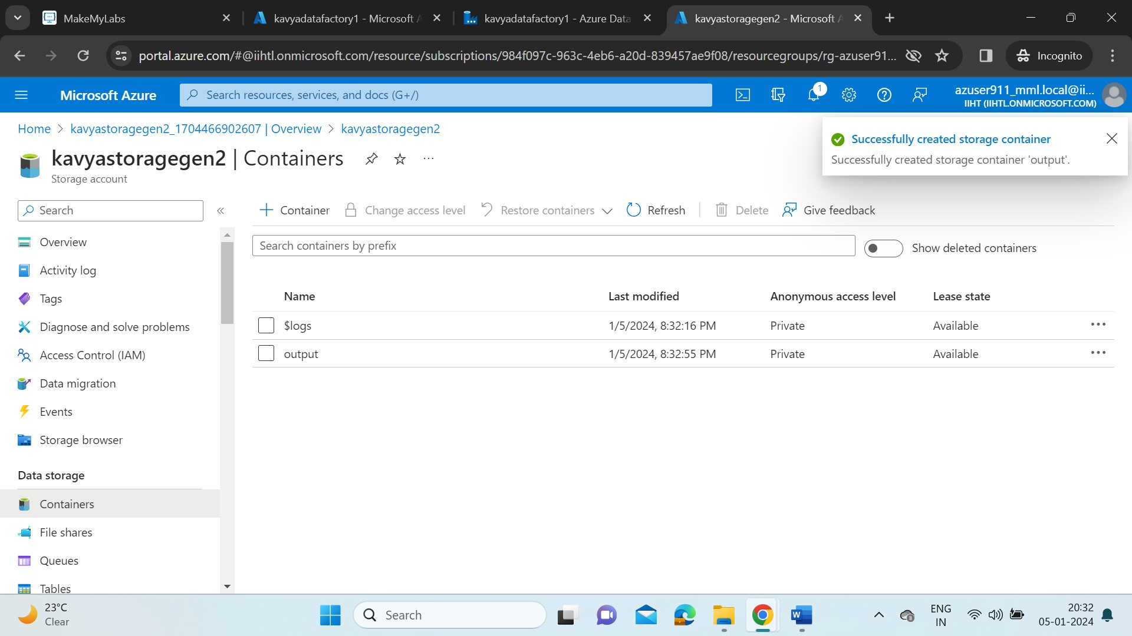

**Create a Data Factory resource:**

* In Azure portal home, search for data factories and create a ADF named “kavyadatafactory1”. After the resource is created, go to resource and click on Launch studio.

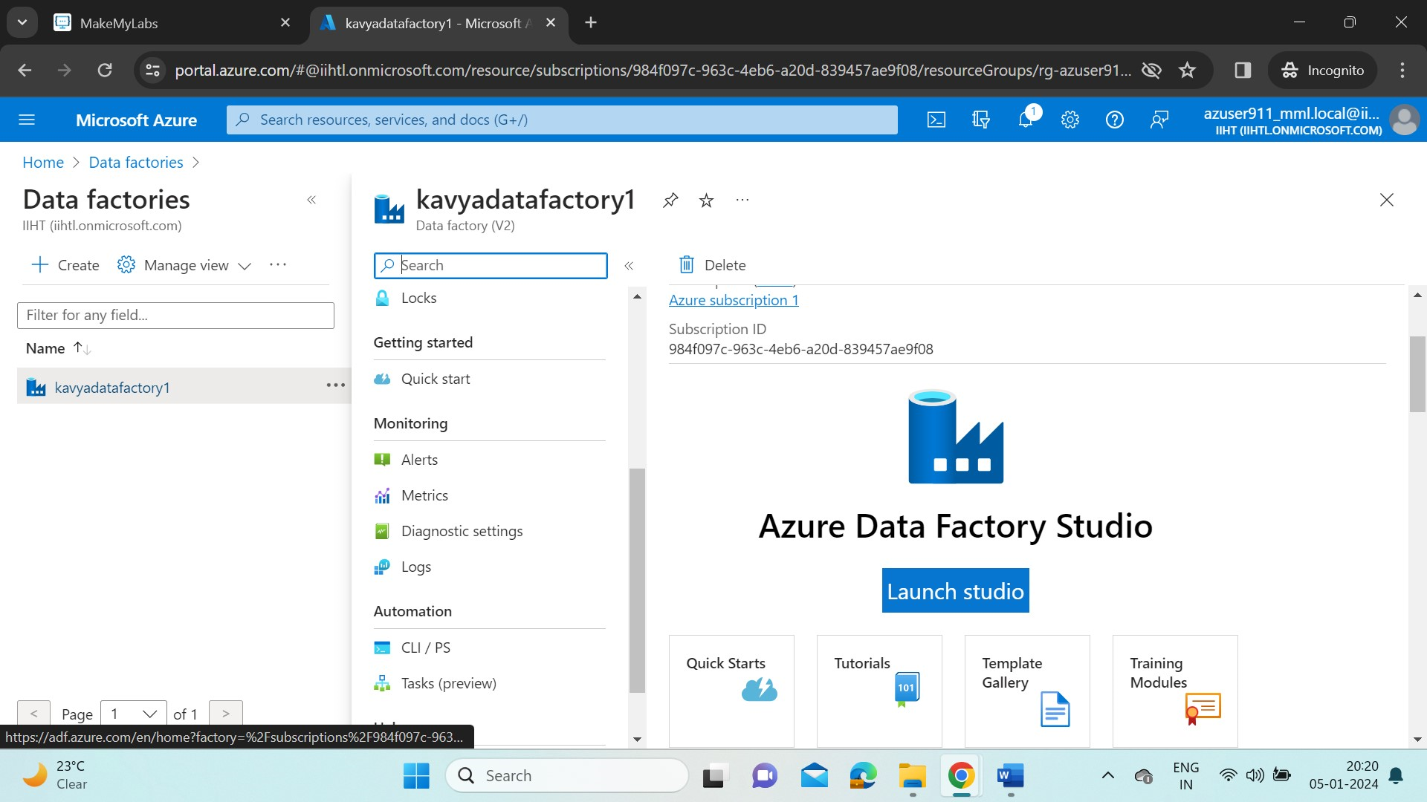

* A new Azure Data Factory portal will opened. Select the Ingest tile to start the copy data tool.

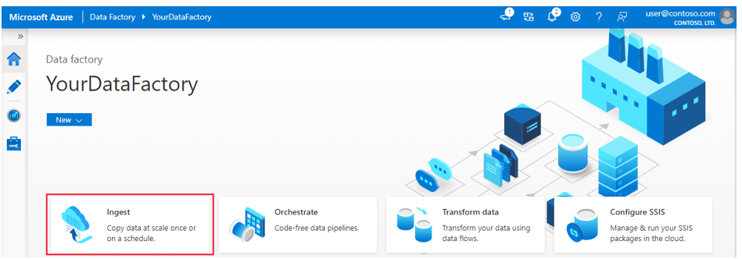

* Select the Built-in copy task and under Task Schedule click Run once now.

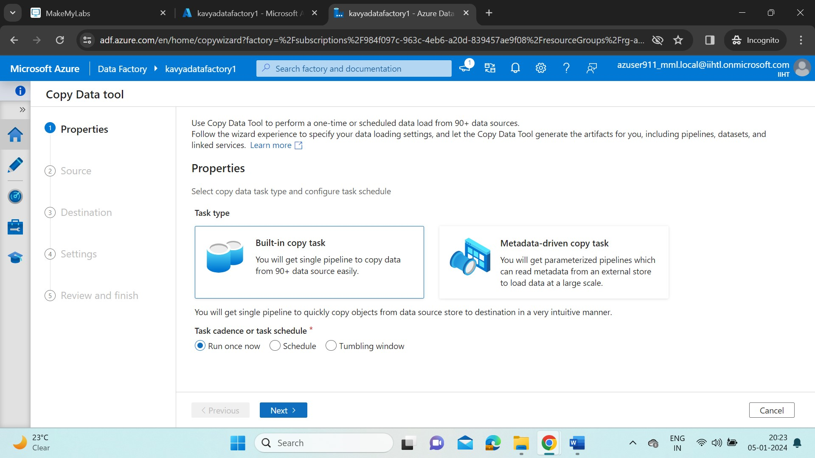

* Now, choose the Source for data ingestion in Pipeline. The type of the storage account created is Azure Blob storage. And for connection, click on new connection and give the name and provide the subscription details with storage account name.
* To check , click on Test Connection. After validation, click on create.

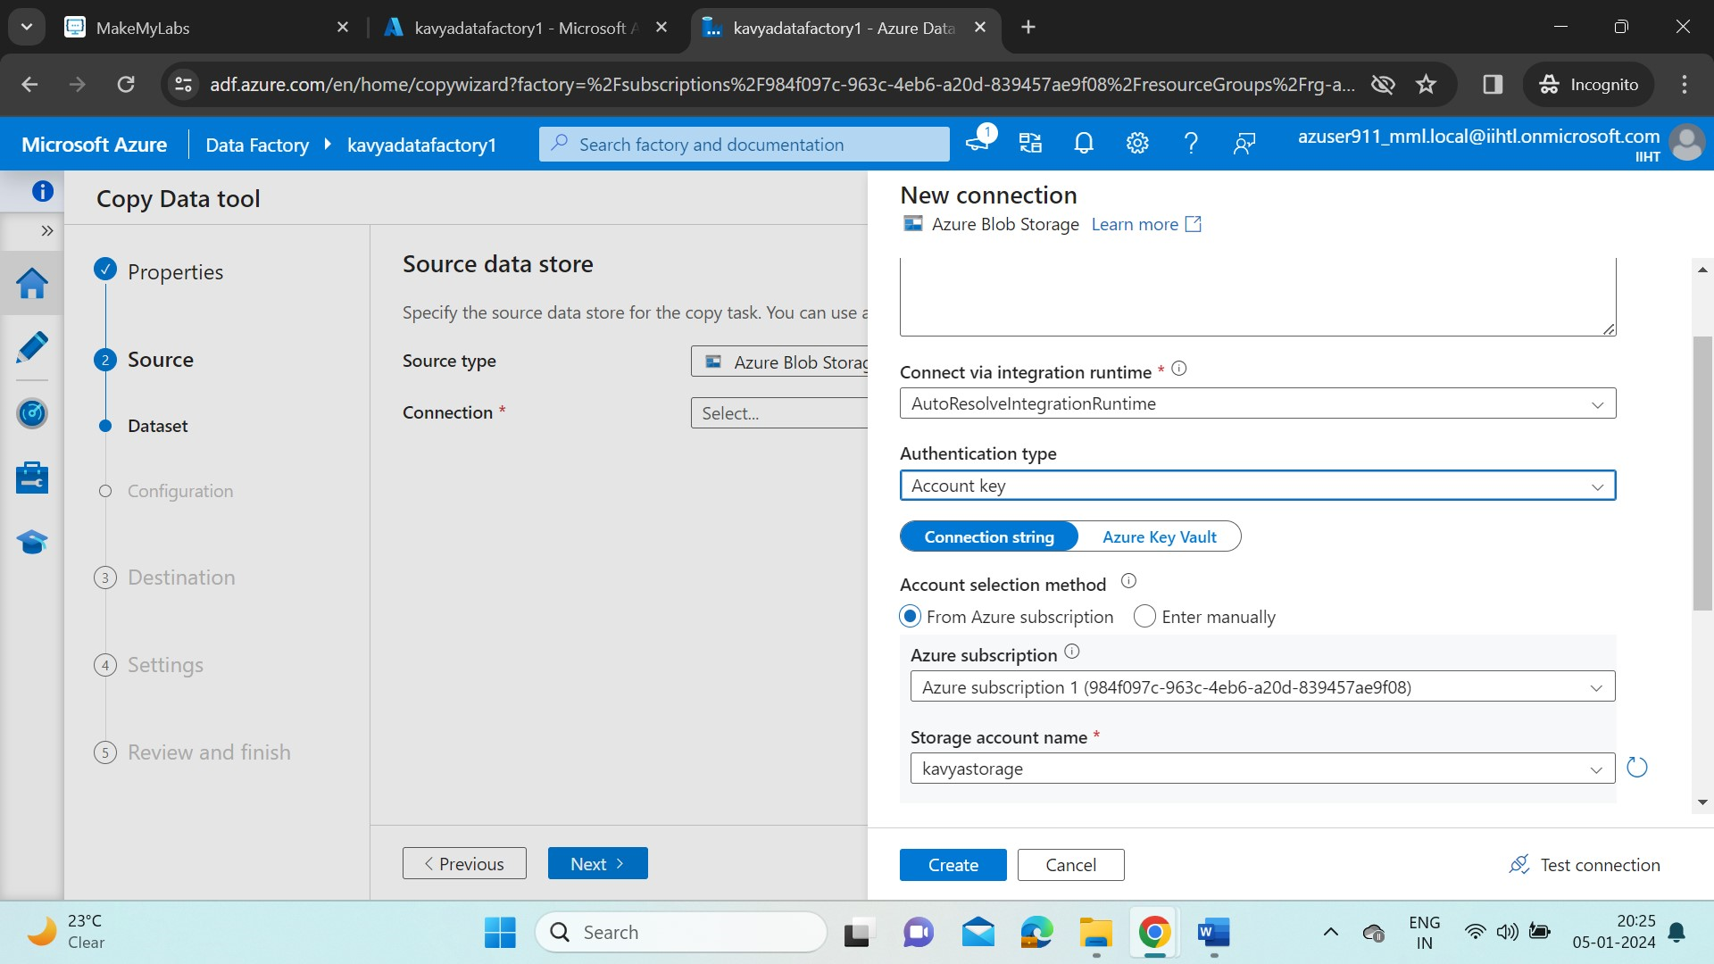

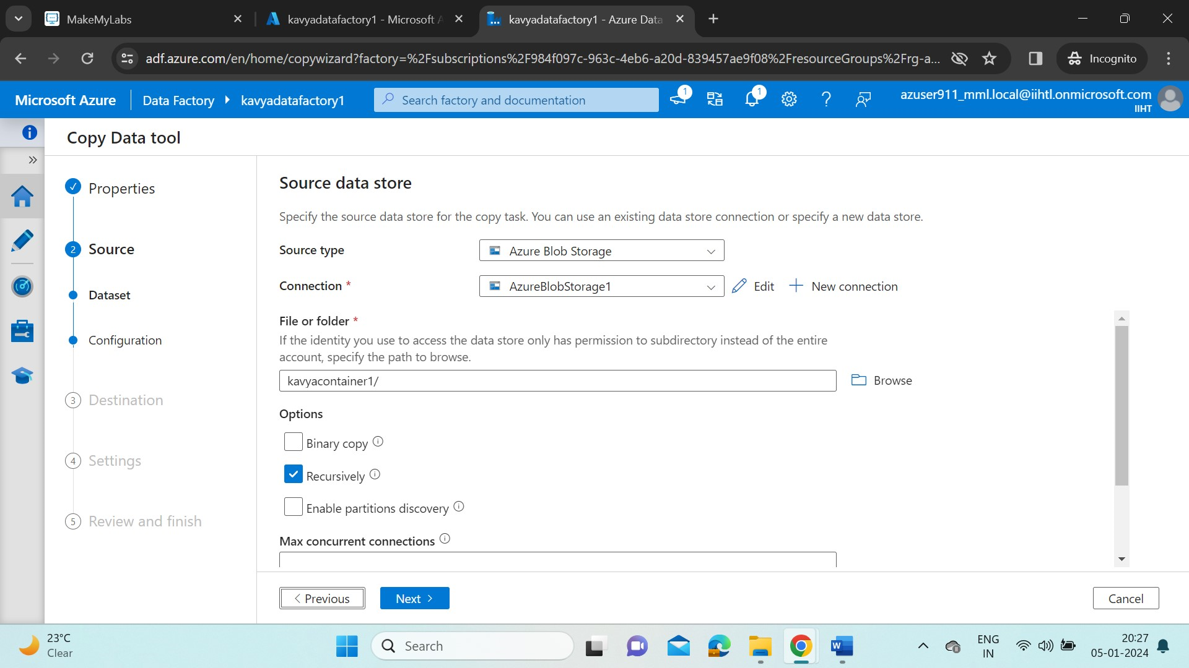

* Provide the path of source folder/file. And enable recursive as we want to run our pipeline whenever we require.
* Now give the destination storage account type(as ADLS Gen2), connection(ADLS Gen1) and provide the destination path to the pipeline.

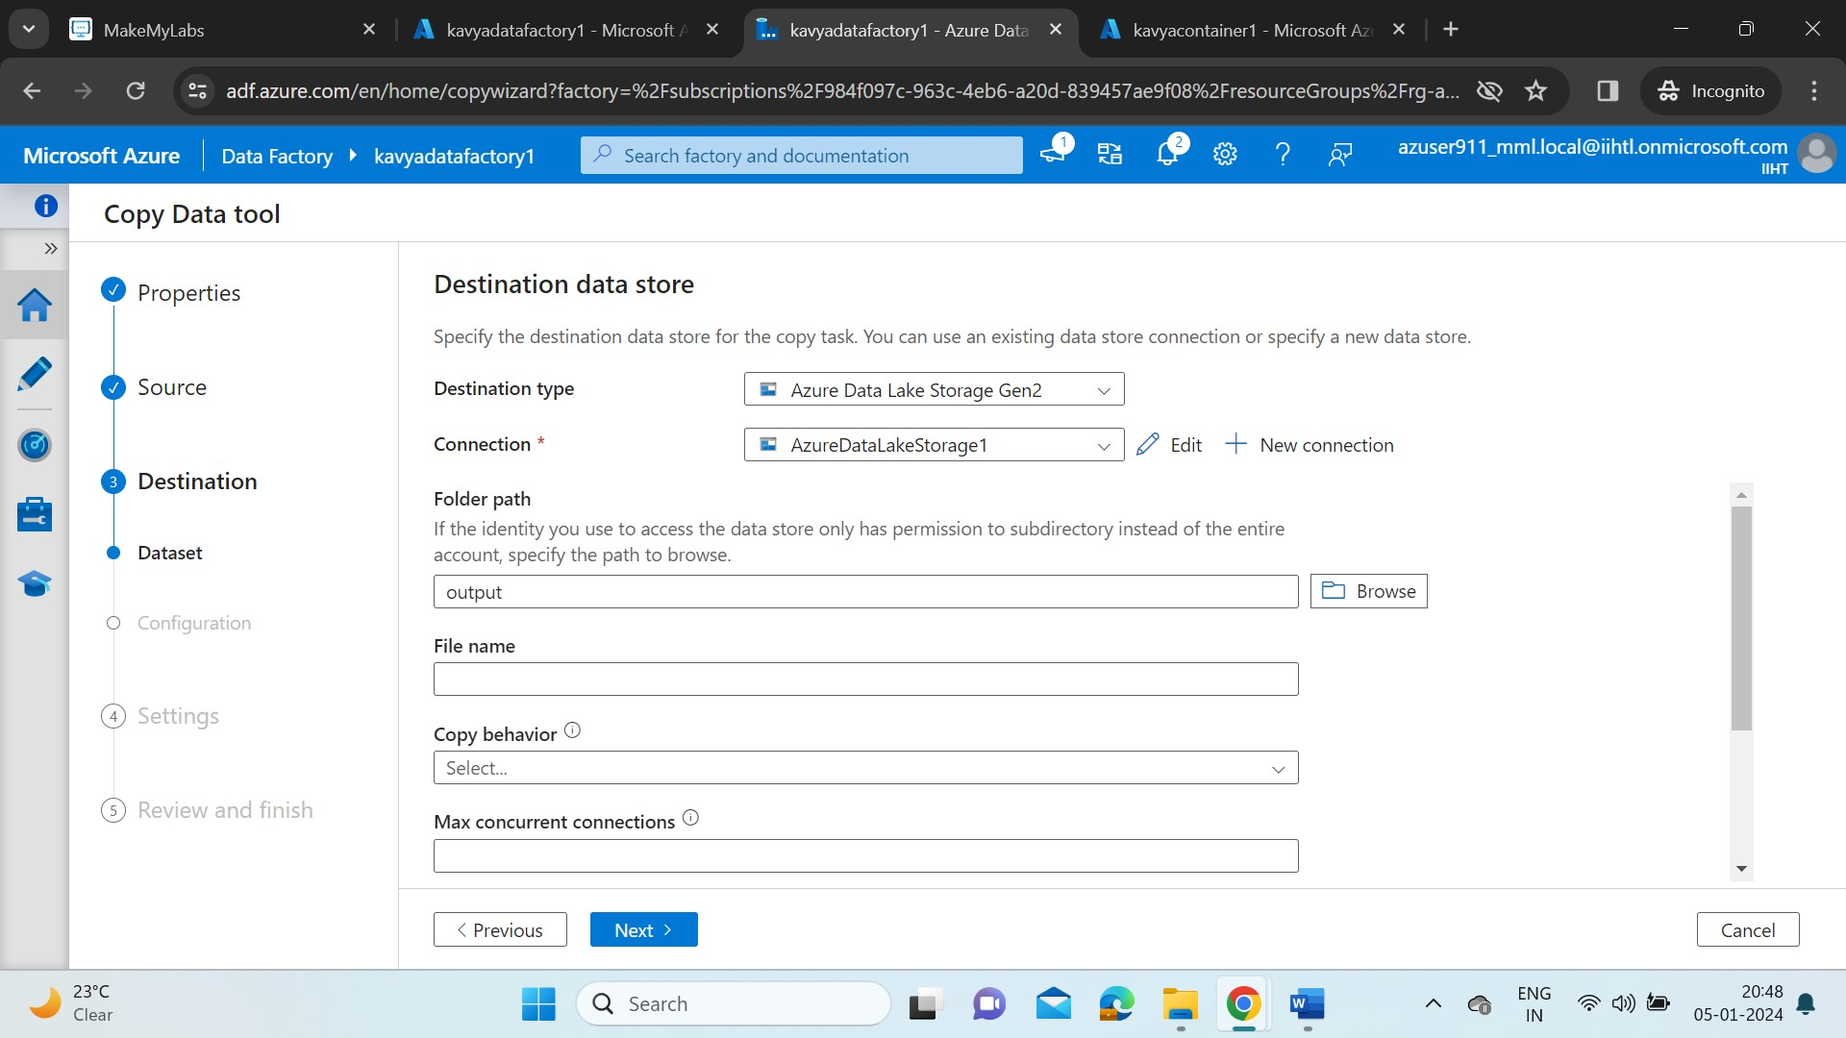

* Now, create a task for pipeline and name it as CopyPipeline_p99.

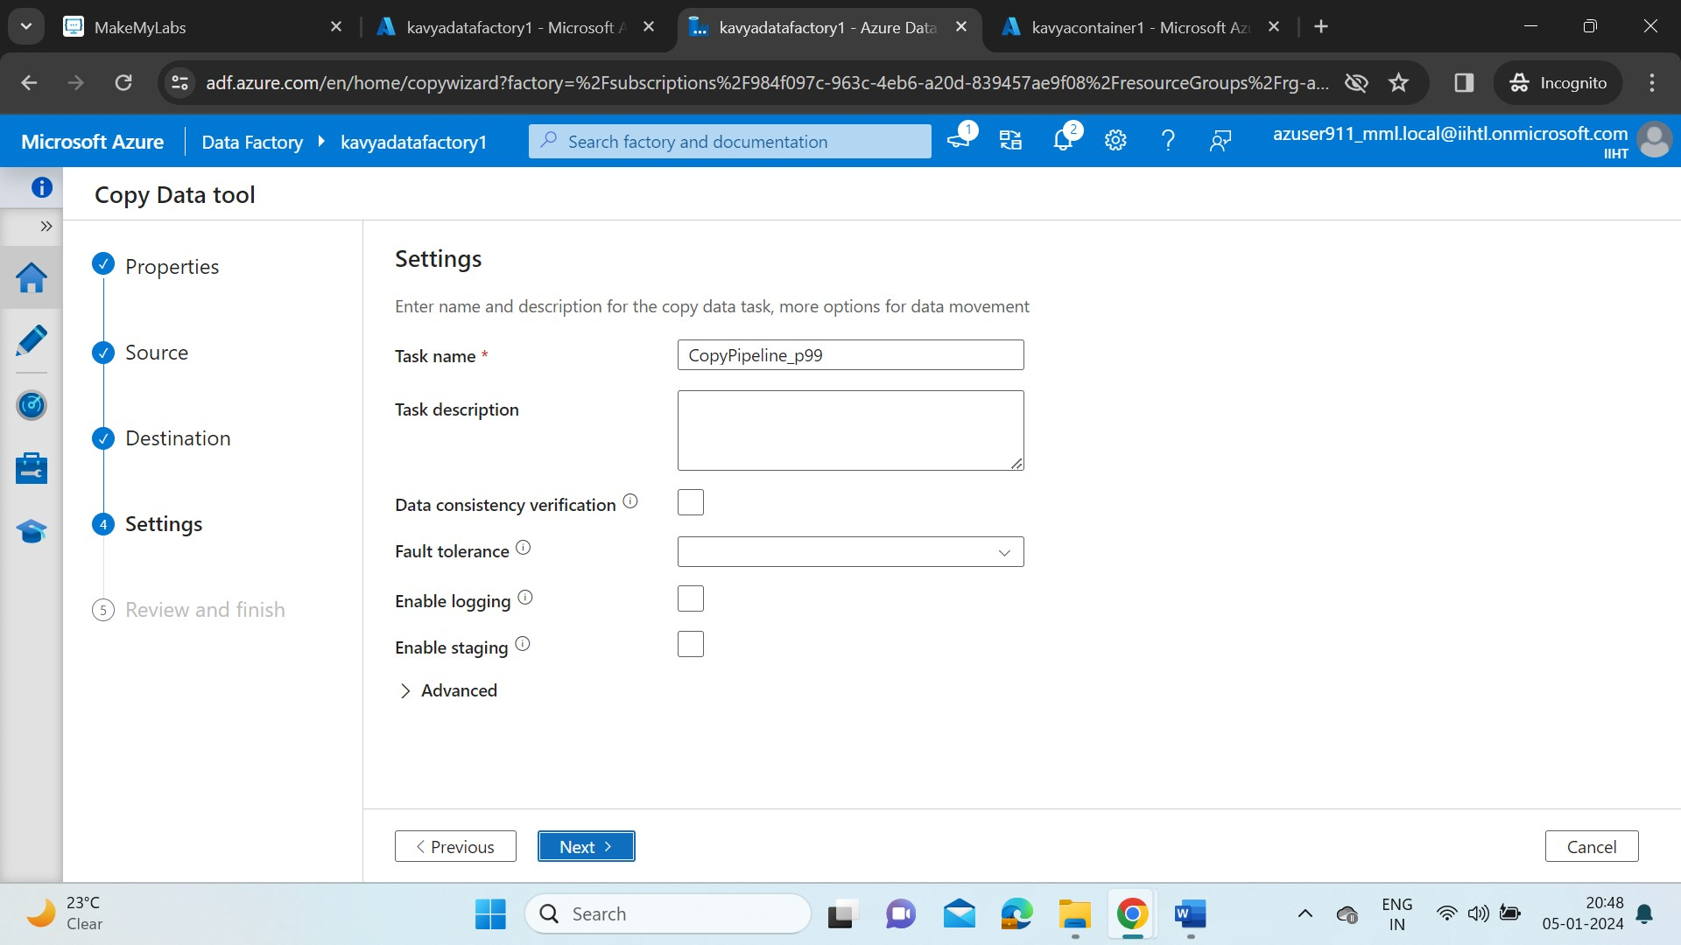

* Click on Next. We can review our pipeline details here. Once it is done, click on Next.

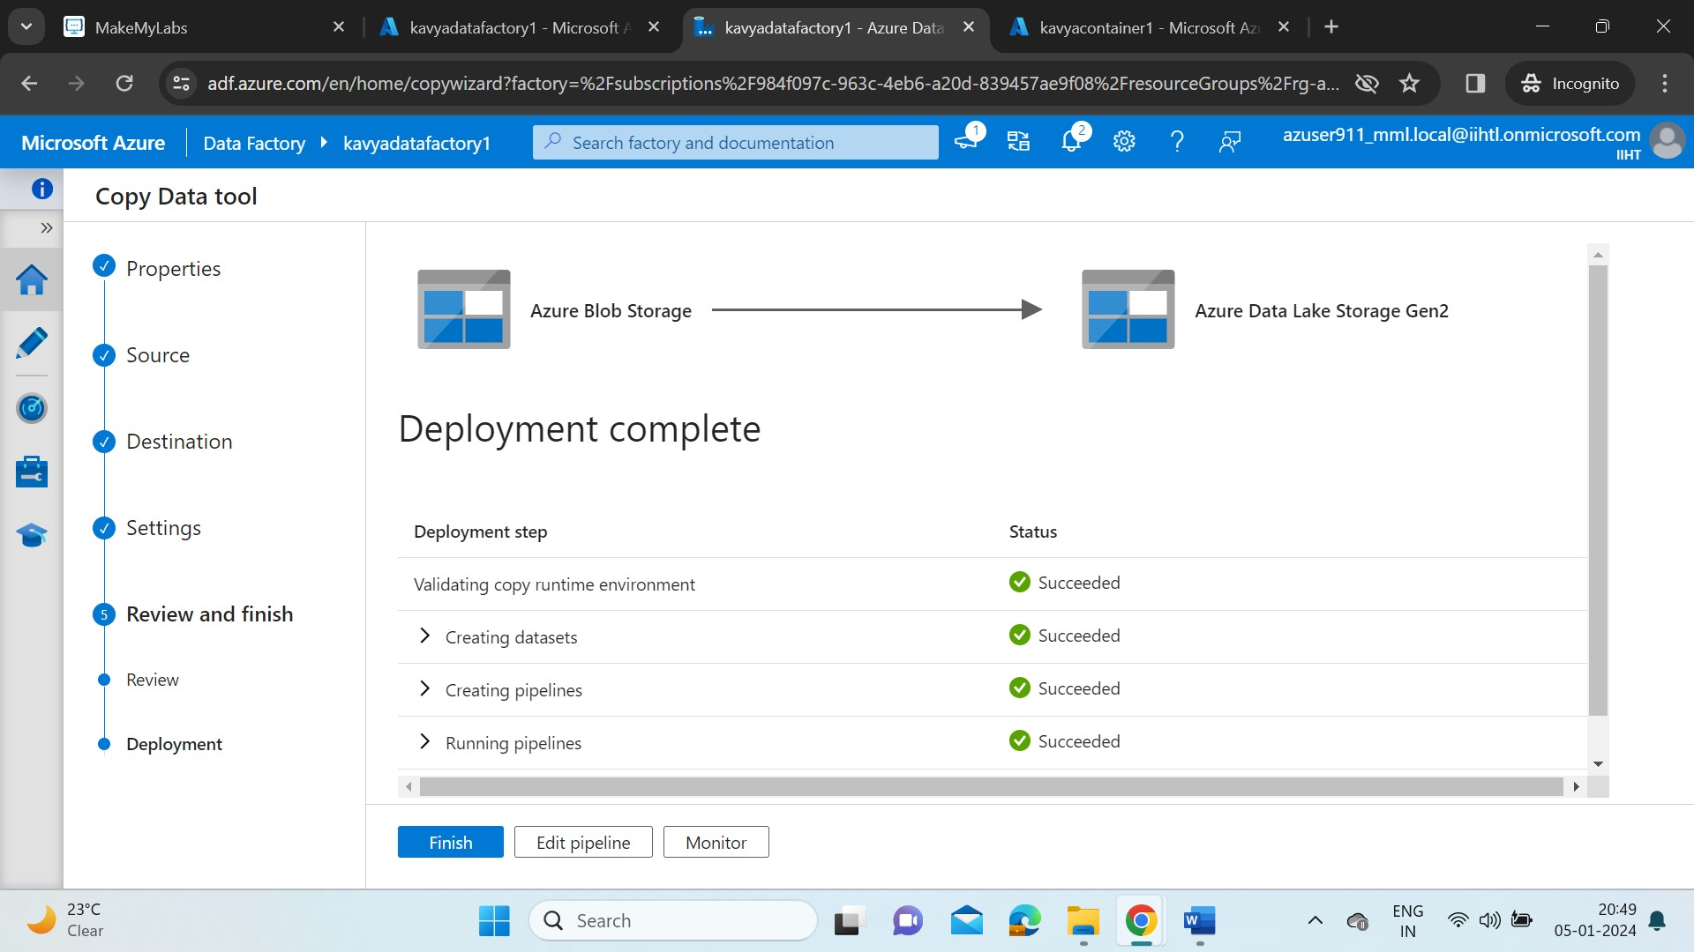

* Here, the tool will show us the status of our deployment task.
* Click on Monitor. In the Monitor tab, it will show us the run details of the task.

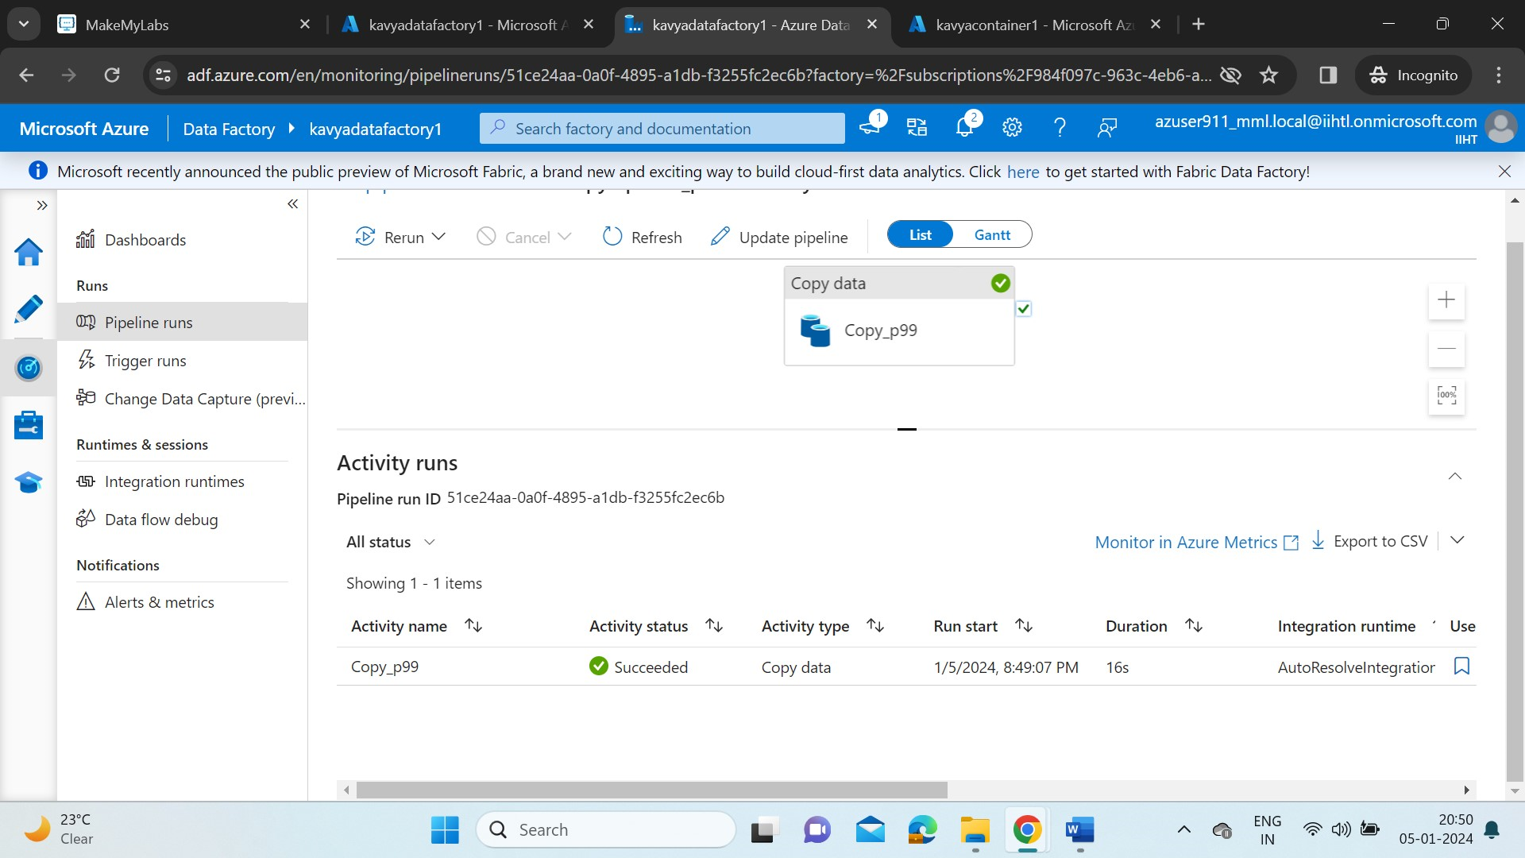

* In the activity tab, we can see our task is success.
* Now check if our destination file is updated with the data we’ve uploaded in source file.

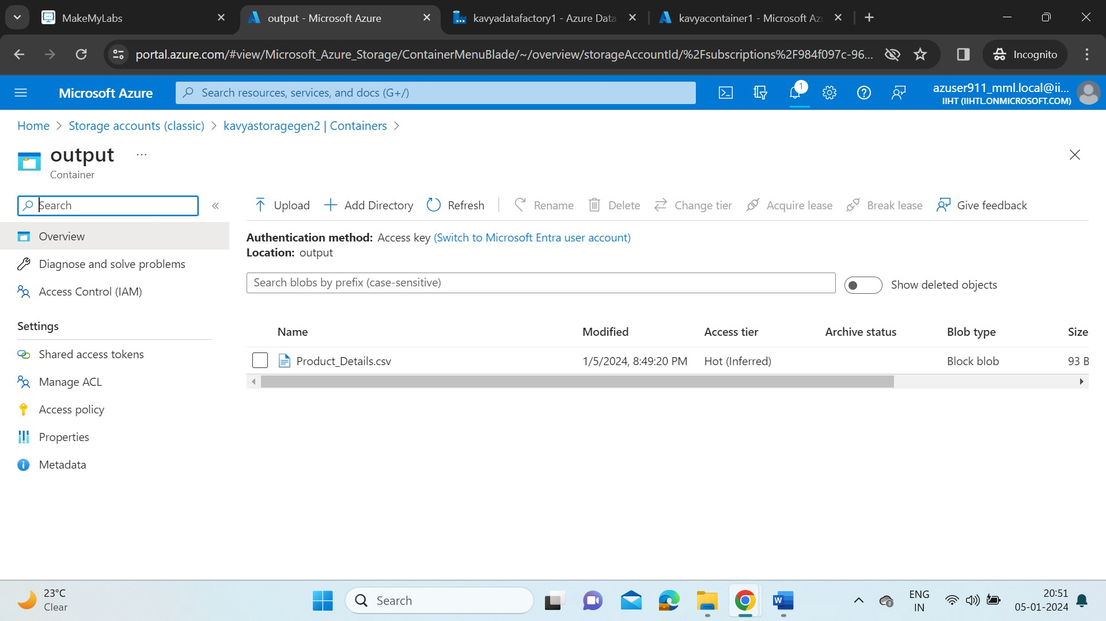

* Product_Details.csv is added to our output container in destination storage account.
* Now we will try adding more files(Added Products1.csv) into our storage account and rerun our pipeline to check if our ingestion is recursive when we add new files.

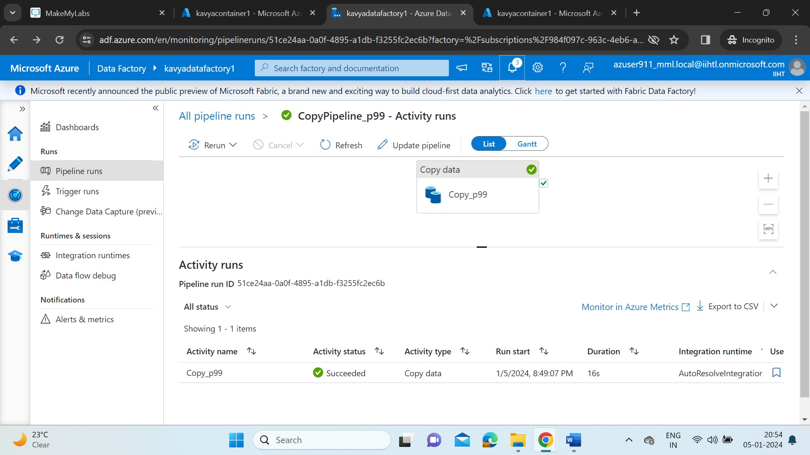

* Click on rerun in the ADF pipeline portal.
* Once again check in the destination storage account, if the file is added.

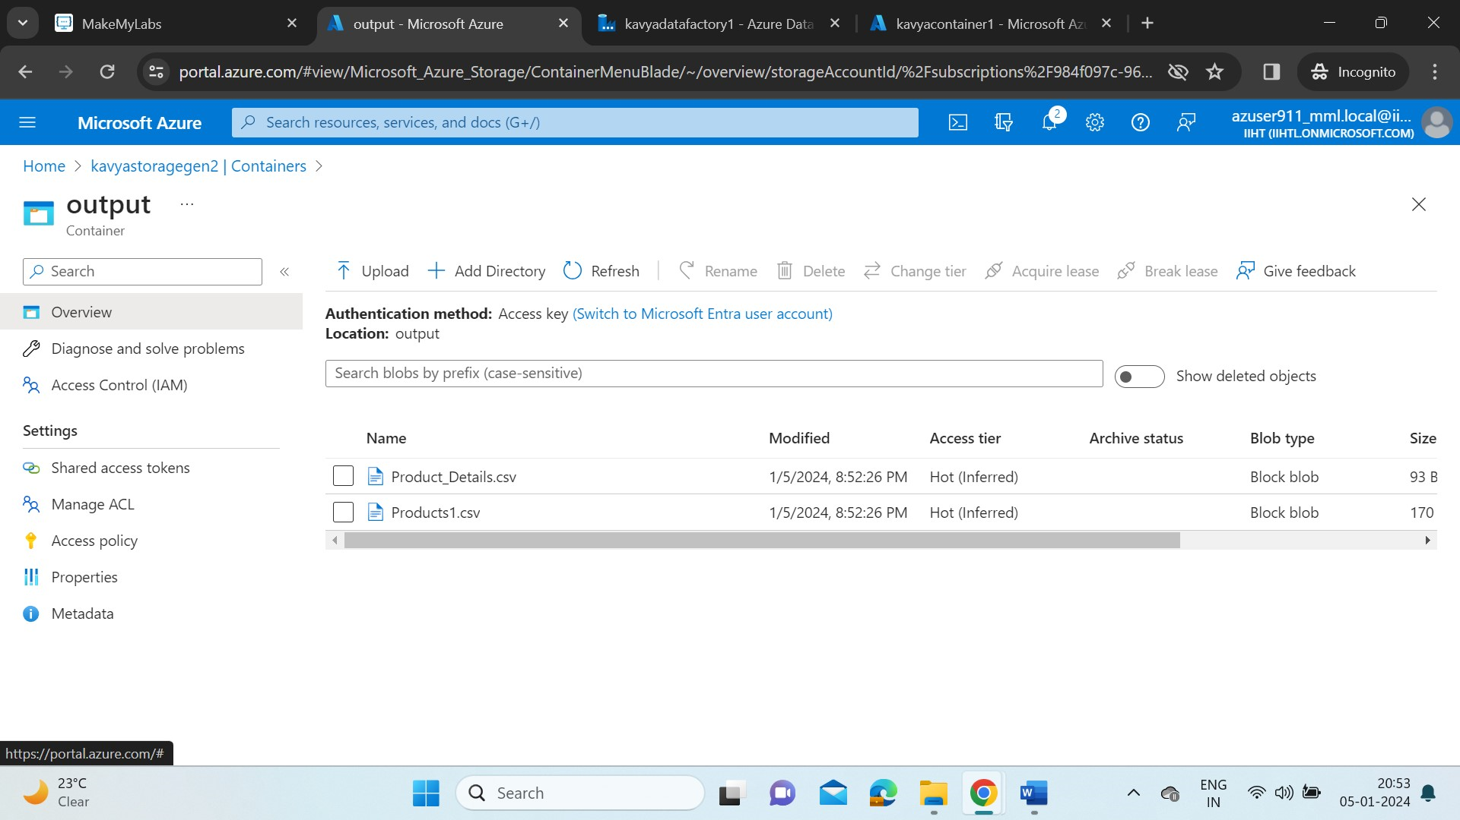

* We can see the file is added here in Output container.
* In this way the ADF allows us to create workflows (pipelines) to move and transform data on a specified schedule.